

|  |  |  |  |  |  |
| --- | --- | --- | --- | --- | --- |
| Programme | : | **B.Tech.** | Semester | : | **Fall 22-23** |
| Course | : | **CSE3002:**  **Internet and Web Programming Lab** | Slot | : | **L9+L10** |
| Faculty | : | **Dr. M. Premalatha** | Marks | : | **10** |

**Date: 20-08-2022**

**Exercise –4**

HTML – **Forms and CSS**

**Note:**

1. **View your registration number in the title bar and snap a screenshot of output along with the title bar.**
2. **Screenshot is required for every modifications of the web page.**

**CSS**

1. Write three sentences about your college life in VIT using a paragraph with division tag. Apply box model style to the div tag using internal CSS. The specification of the box model is given below.

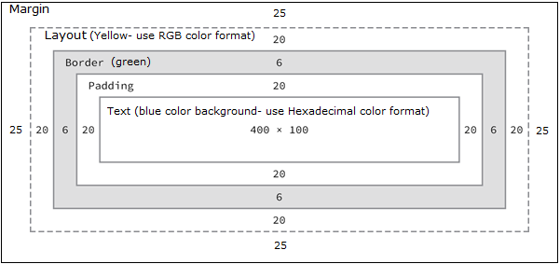

2. Include your favorite singer’s photo as an image. Add a video control to play any of his trending song. Add a CSS class named myphto that fulfils the following requirements:

* The image border is rounded, so that it appears as a circle.
* The image width and height are both 150px.
* The image has a solid border, has a width of 2px, and be colored black.
* Add title to the image and apply font change and color change animation effect. Use percentage to apply different colors and change font size.

For example, the image should look like Fig1:



Fig. 1. Photo

**JavaScript**

1. A General Service company hired you to calculate the labour cost and total charge for the services rendered to their client based on the formula given below:

Rate per hour : Rs.45/-

Labour cost : Rate per hour * hours work

Total Charge : Labour cost + Cost of Materials.

Write a JavaScript program (Internal) using suitable pop up boxes to read the necessary inputs and display the output.

1. Write a JavaScript program that initializes a value for the variable ‘p’ and displays the prime numbers between 1 and the value initialized for ‘p’. The values should be printed in an HTML table.
2. Write a JavaScript program to accept your reg.no and display it as shown below by applying inline style (2 marks)

